Why is having a goal important? Because people you network with want to help you but can only engage if you are clear and precise about what you are hunting for. Because hiring managers want to hire someone who is committed and passionate about their job, their industry and their company. Because it will help you increase the odds of winning a job, spending your time researching in the area you aim at, and will help you build confidence.

Exercise #1: The Warm-Up
What’s in Your Bulls-Eye?

The city:
The function:
The industry:
The company:
Other criteria:

Exercise #2: The Worksheet
What is Your Job Search Goal?

Rank | Step 1: What Cities you Prefer
1
2
3
4
5
6

Rank | Step 2: Title, Description
1
2
3
4
5
6

Rank | Step #3: Industries You Prefer
1
2
3
4
5
6

Some examples to draw from:

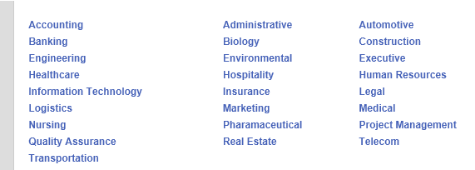

Step 4: Companies within each of your Preferred Industries
Industry #1 | Top Companies | Link to their Career/Job Site

Industry #2 | Top Companies | Link to their Career/Job Site

Industry #3 | Top Companies | Link to their Career/Job Site

Industry #4 | Top Companies | Link to their Career/Job Site

Industry #5 | Top Companies | Link to their Career/Job Site

Industry #6 | Top Companies | Link to their Career/Job Site

Step 5: Your Private Attributes

These attributes are personal. If you had two or three job offers, how would you distinguish amongst them? How would you decide? These are things to examine as you are researching positions, talking to companies, and asking your network.
These attributes are NOT things you probe in an interview or share broadly as they can be mis-interpreted.

EXAMPLE Personal Attributes* | EXAMPLE Criteria per Attribute
Pay range | Min $X salary or $X per hour
Training Program | Yes or no
Size company | Fortune 500, Medium, Small, Start-Up
Health benefits | Yes or no and how important is this to you if not
Car Allowance | Company car and/or expenses or none
Product | Good product, sellable, something you understand
People Attributes | Team culture, leader's management style
Commute | No more than X miles from home one way
Flex Hours | Yes or no
Flex Work Location | Can you work from home periodically
Vacation time | How much

*NOTE: These are NOT items you ask about in an interview. Once you have an offer in hand, you can probe on some. Other items can be researched on the internet via company alumni boards on LinkedIn and web searches. Some you may never know until you start!

FINAL – Step 6 – Write Your Job Search Goal

Your test and assignment: Answer “So, what are you looking for?”

Bad Answers (Goal statements):
- “I’m flexible; I can do a lot of things”
- “Well, my background is in ______________ and _____________”.
- “I’m looking for an exciting position that leverages my background in finance and where I can work with great people…”

Good Answer (Goal statement):
- I’m looking for a sales position in Chicago with a large corporation in the medical or manufacturing industry.
- I have been doing a lot of research and I am very focused on two types of career opportunities. One is a logistics manager in a distribution center here in Orange County. However, I’m also looking at opportunities in teaching logistics at local educational centers.

Now, write out YOUR goal statement here, based on the work you did above.
My Goal Statement:

Congratulations! You are ready to share your goal statement with your network. Say it proudly and with confidence. There ARE jobs out there that meet your goal and YOU will meet the needs of a hiring manager.

